Object Oriented Design and Programming

**Workshop2**

Go through the questions below and answer the questions:

1. Taking length and breadth of a rectangle from user and check if it is square or not.

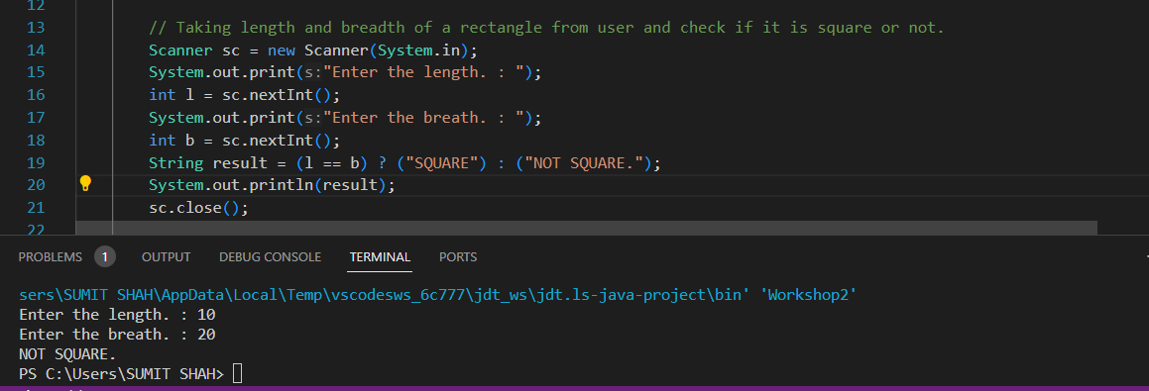

1. A college has following rules for grading system:

a. 40 to 50 - C

b. 50 to 60 - C+

c. 60 to 70 - B

d. 70 to 80 - B+

e. 80 to 90 - A

f. Above 90 - A+

Ask user to enter marks and print the corresponding grade using if-else-if statement.

1. Determine oldest and youngest among the people taking the using input.

1. If

x = 2

y = 5

z = 0

then find values of the following expressions:

a. x == 2

b. x != 5

c. x != 5 && y >= 5

d. z != 0 || x == 2

e. !(y < 10)

1. Ask student if he/she has medical cause or not ( 'y or 'n' ). if (‘y’) print you are not allowed to sit in the exam and if(‘n’’) print you can sit in the exam.

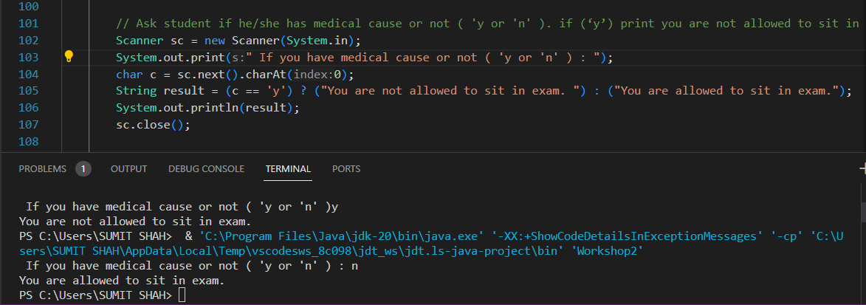

1. Write a program to check the odd and even numbers using user input.

1. Write a program to print the value of x ,if and only if the value of x is x>5 and less x<15 taking user input.

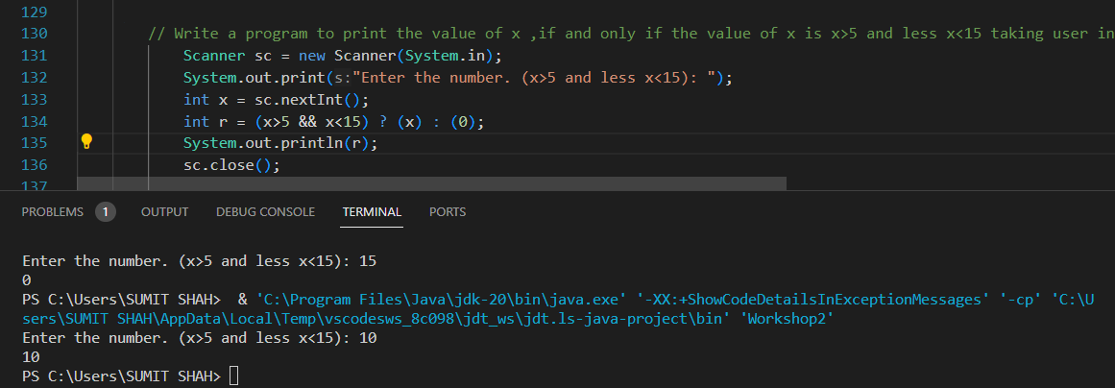

1. Assuming the value: x=20,y=15,z=10.Complete the code below and observe the result.

if (x > y)

{

if (y > z){ System.out.println("x is greater than y and z");} // statement1.

}

else

System.out.println("x is less than or equal to y"); // statement2.

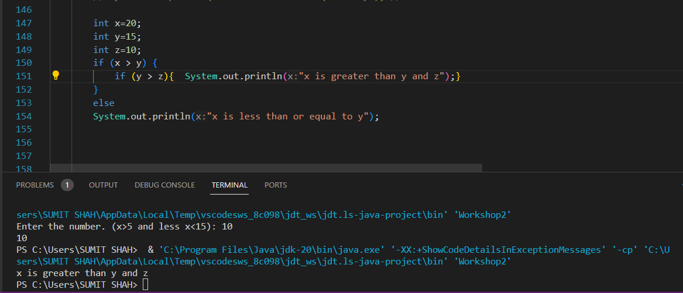

1. A college has following rules for grading system:

a. grade -A+ print ("Excellent !")

b. grade -A print ("Outstanding !")

c. grade -B+ print ("Good !")

d. grade -B print ("Can do better !")

e. grade -C+ print ("Just Passed !")

f. grade -C print ("You Failed !")

print ("Invalid grade!") for default case

Ask user to enter grade and print the corresponding grade using switch statement

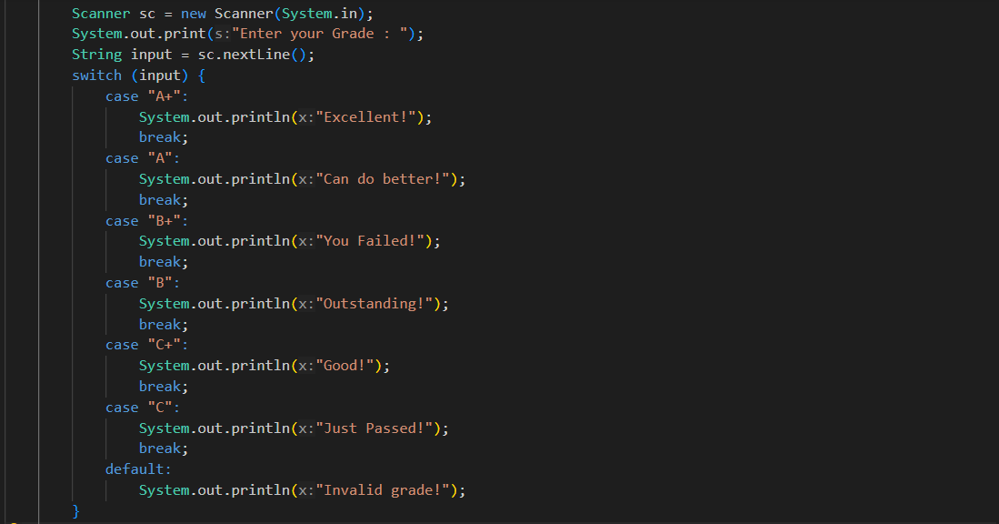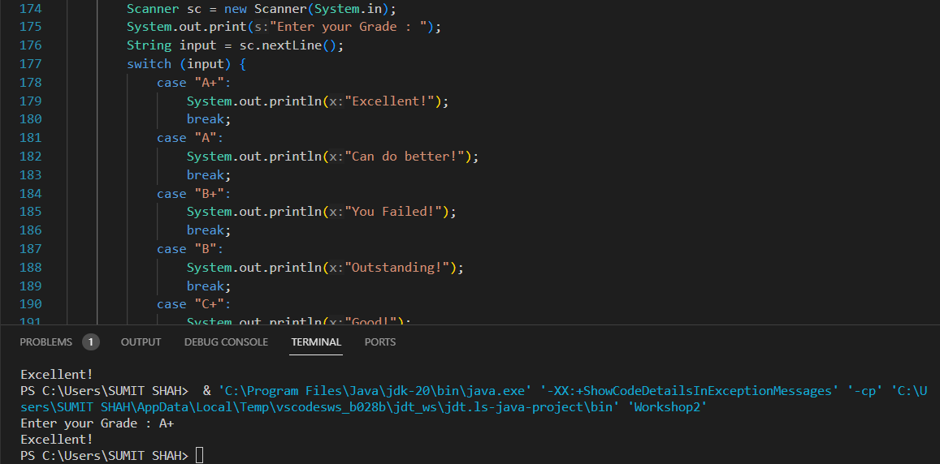

1. Run the code below and observe how the break statement works.

**class** Student {

**public** **static** **void** main(String[] args) {

**int** roll_no = 12;

**switch** (i) {

**case** 1:

System.out.println("Your roll number is 10");

**break**;

**case** 2:

System.out.println("Your roll number is 12");

**break**;

**default**:

System.out.println("Your roll number is greater than 12");

}

}

}

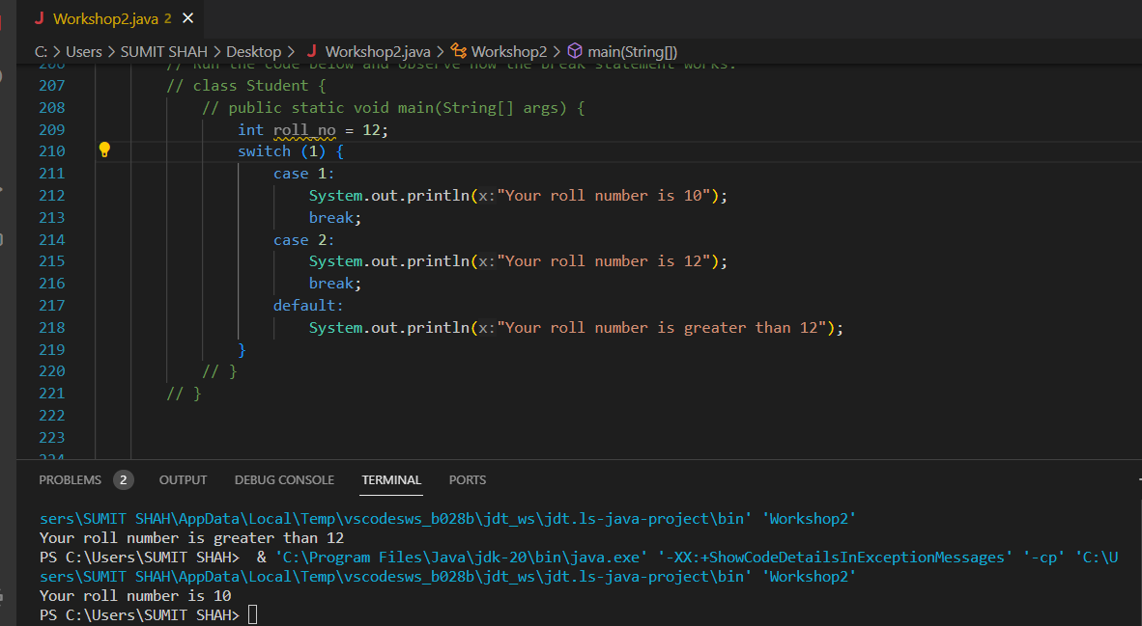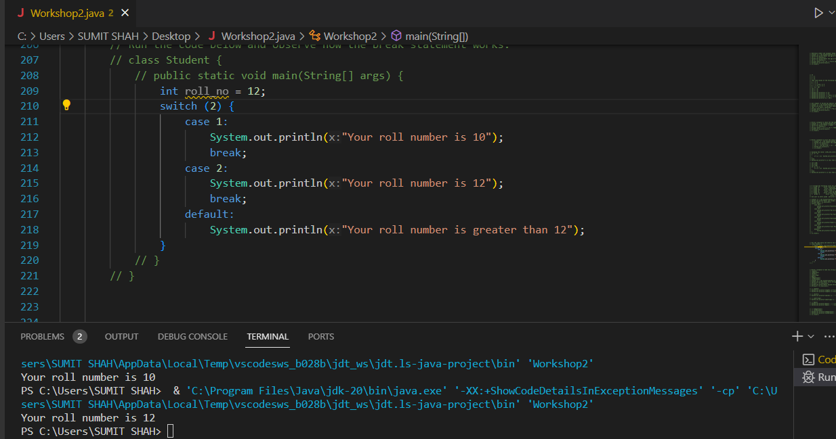

1. Write a program to take two string user input and perform the following string methods and observe the result
2. length()
3. compareTo()
4. charAt()
5. substring()
6. Equals
7. toUpperCase()
8. toLowerCase()



